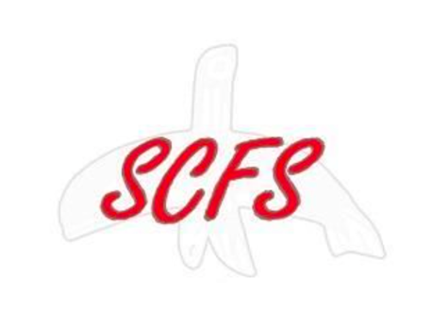

**Procedure for applying for the Emergency Food Voucher Assistance Program (EFAP)**

Steps​ ​(if you qualify, please follow these steps)

1. Fill out application
2. Send or mail, along with required documents to
   1. jchristoe@comcast.net
   2. Jona Christoe, 146 So. 294th Place, Federal Way, WA 98003
3. Once approved and you have received Voucher, redeem at nearest participating store

Required Documents along with the application

1. Current photo ID card (state or tribal)
2. Copy of proof of income for the past 30 days
3. Signed Client Release of Information form (included in application pdf)